PROJECT TITLE
Automating Employee Data ServiceNow Platform

Abstract
This project focuses on automating employee data management using the ServiceNow platform. Organizations often maintain large amounts of employee information such as name, employee ID, department, designation, and contact details. Managing this data manually may lead to errors, data duplication, and time‑consuming administrative work. The ServiceNow platform provides automation capabilities through Import Sets, Transform Maps,
and data relationships that help organizations efficiently manage employee records.
In this project, employee data is imported from external files such as Excel and automatically transformed into the ServiceNow employee table. The system reduces manual work, increases data accuracy, and improves data consistency.
Automation also enables faster processing of employee records and easier management of organizational information.

Introduction
- Employee data management is an essential part of every organization. Human resource departments handle a large volume of employee records including personal details, department information, job roles, and reporting structures. When this information is handled manually, it may lead to errors and inefficiencies.
- Modern organizations use automation tools to simplify this process. ServiceNow is a cloud‑based platform that allows organizations to automate workflows and manage enterprise data efficiently. It provides several tools such as Import Sets, Transform Maps, and Flow Designer to automate
data import and management.
- This project demonstrates how employee information can be automatically imported into ServiceNow. The automation reduces manual work and ensures accurate employee records. The system also allows
relationships between tables such as employees, departments, and managers to be managed easily.

Problem Statement
Many organizations still rely on manual entry of employee data into management systems. Manual data entry is slow and may result in incorrect or incomplete information.
Common problems include:
• Duplicate employee records
• Incorrect department assignment
• Time‑consuming data entry process
• Lack of centralized employee data management
Therefore, an automated system is required to import and manage employee data efficiently using the ServiceNow platform.
Objectives
The main objectives of this project are:
• To automate the process of importing employee data into ServiceNow.
• To reduce manual effort in employee data entry.
• To ensure accurate and consistent employee records.
• To establish relationships between employee and department tables.
• To improve overall HR data management efficiency.

Scope of the Project
The scope of this project is limited to employee data management using the ServiceNow platform. The system focuses on importing employee details from external files and storing them in ServiceNow tables.
The project includes:
• Creating employee tables
• Importing employee data
• Transforming data using Transform Maps
• Linking related tables using dot walking
• Automating updates and notifications
The project does not include advanced HR management features such as payroll processing or performance evaluation systems.

Literature Review
Enterprise platforms such as ServiceNow, SAP, and Oracle are widely used to manage organizational data. ServiceNow has gained popularity because of its flexibility and cloud‑based architecture. Research shows that automation in data management improves accuracy and reduces operational costs. Import tools and data transformation features allow organizations to integrate information from multiple sources. ServiceNow provides Import Sets and Transform Maps that help organizations import large datasets efficiently. These features are commonly used in HR systems, IT service management, and customer support applications.

Tools and Technologies
Platform: ServiceNow
Technologies used in this project:
• ServiceNow instance
• Import Sets
• Transform Maps
• Employee database tables
• Dot Walking
• Flow Designer for automation
These technologies help in importing, transforming, and managing employee data efficiently.

Modules of the System
The project consists of the following modules:
1. Employee Data Import Module
This module uploads employee data into ServiceNow using Import Sets.
2. Data Transformation Module
Transform Maps convert imported data fields into the correct table fields.
3. Employee Record Management
This module stores employee details in the ServiceNow employee table.
4. Relationship Mapping
Dot walking connects employee records with department and manager tables.
5. Automation Module
Workflows or Flow Designer automatically update records when new data is imported.

Identification Phase
The identification phase is the initial stage of the project where the problem is identified. In many organization, employee ID, name, department, designation, and contact details are managed manually. Manual data entry may lead to errors, duplication of records, and delays in data processing. Therefore, the need for an automated system was identified. The ServiceNow platform was chosen to automate the process of managing employee data efficiently.

Requirement Analysis
In this phase, the requirement needed for the system are analyzed. The system should be able to import employee data form external sources such as Excel files and store them in ServiceNow tables. The system must ensure data accuracy, avoid duplication, and maintain relationships between employee and department records. It should also support automation features for easy management of employee information.

Project Planning Phase
The project planning phase involves planning the activities required to complete the project successfully. In this phase, the project objectives, scope, and tools are defined. The technologies used in this project include the ServiceNow platform, import sets, Transform Maps, and Flow Designer. A clear plan is created for developing the system, importing employee data, mapping fields, and verifying records.

Project Development Phase
In the development phase, the actual system is developed using the ServiceNow platform. The employee table is created to store employee information. Import Sets are used to upload employee data from Excel files. Transform Maps are configured to map the imported data fields to the correct fields in the employee table. This phase ensures that employee records are automatically processed and stored in the system.

Project Design Phase
The design phase focuses on designing the structure of the system. The database structure and relationships between tables are designed in this phase. Employee records are connected with department and manager tables using dot walking. The system modules such as employee data import, data transformation, record management, and automation are also designed to ensure efficient data management.

Project Documentation
Project documentation includes recording all the details related to the project. It contains information such as project title, abstract, introduction, objectives, tools and technologies, system modules, implementation steps, and conclusion. Proper documentation helps in understanding the working of the system and is important for academic submission and evaluation.

Project Demonstration
Project demonstration is the final phase where the completed project is presented. In this phase, the working of the system is demonstrated using the ServiceNow platform. The process of importing employee data, transforming the data into employee tables, and managing records is shown. The benefits such as reduced manual work, improved data accuracy, and faster data processing are also explained during the demonstration.

Implementation
The implementation process involves configuring ServiceNow to automate employee data management.
Steps include:
• Creating an employee table
• Creating an Import Set table
• Uploading employee data files
• Mapping fields using Transform Maps
• Running the transform process
• Verifying employee records
Once the system is configured, employee data can be imported automatically.

Step by Step Procedure
Step 1: Login to the ServiceNow platform.
Step 2: Create a custom Employee table.
Step 3: Prepare employee data in Excel format.
Step 4: Create an Import Set table in ServiceNow.
Step 5: Upload the employee data file.
Step 6: Create a Transform Map to map fields.
Step 7: Run the transform process.
Step 8: Verify imported employee records.
Step 9: Use dot walking to connect related tables.
Step 10: Automate updates using Flow Designer.

Screen layouts

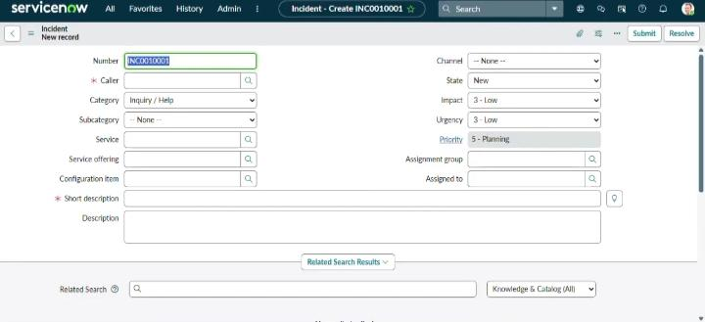

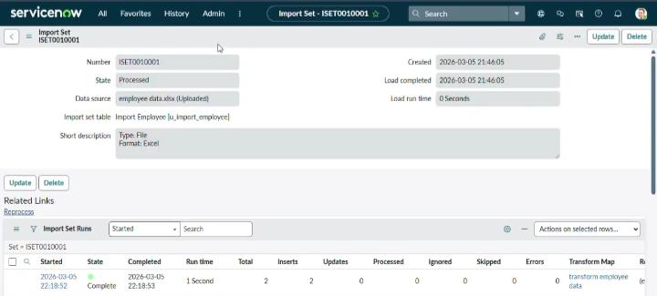

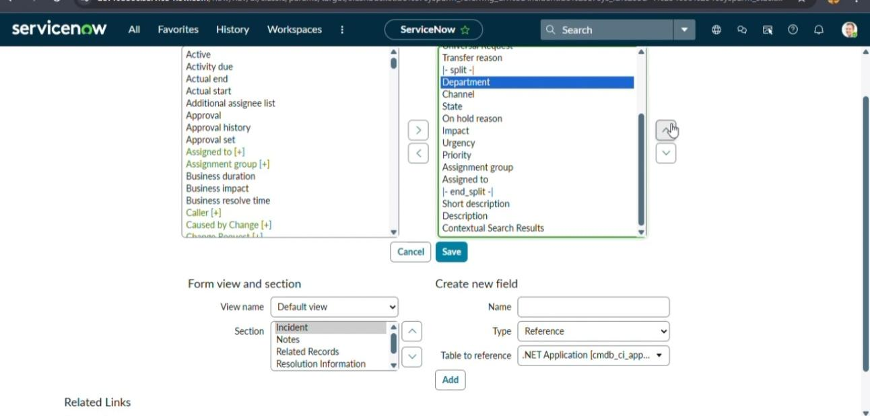

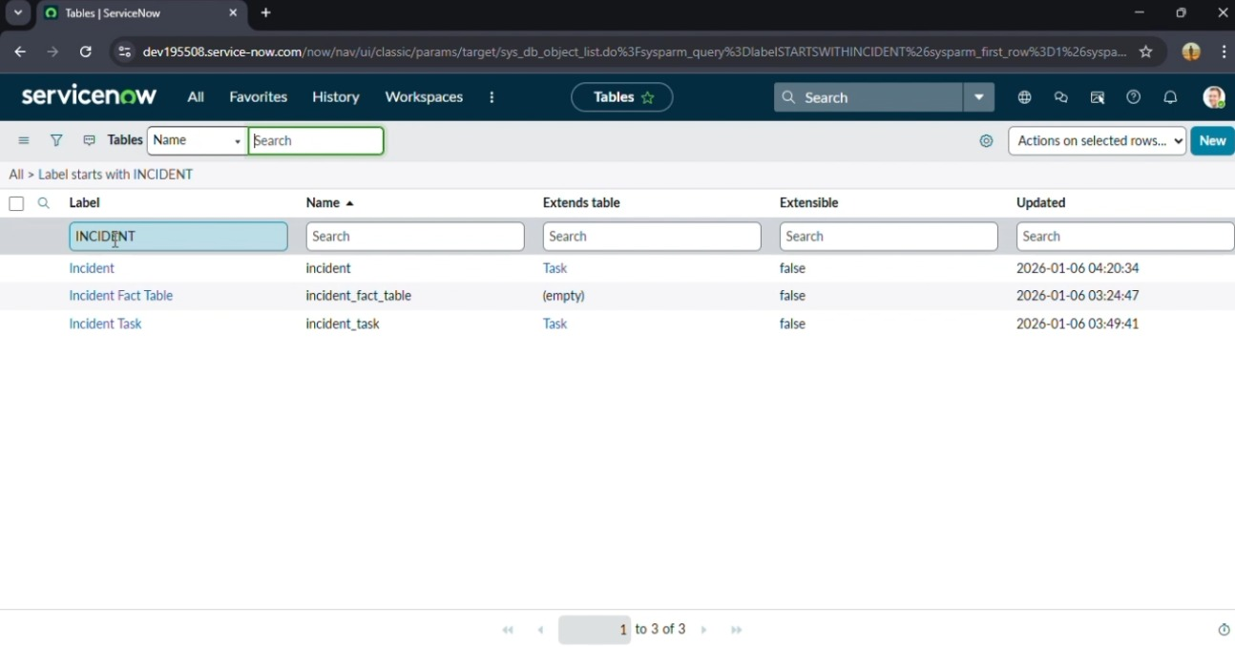

Conclusion
Automating employee data management using ServiceNow improves organizational efficiency. The system reduces manual errors, saves time, and ensures accurate employee records. By using Import Sets, Transform Maps, and automated workflows, organizations can manage large volumes of employee data effectively. This project demonstrates how ServiceNow can sbe used as a powerful platform for enterprise data automation.

